Heilyn Fuselier — Fiserv Onsite Study Guide
Read-aloud practice version, in English — Onsite: September 8, 2026, 9:00 AM, with Avinash Pandey

0. Opening — "Tell me about yourself"
This is almost guaranteed to be the first question. Read it out loud until it flows naturally without sounding memorized.
I'm an SDET and Test Automation Engineer with over ten years of experience across software engineering, QA automation, backend validation, API testing, SQL development, and production support.
Most recently I've been focused heavily on automation using Java, Selenium, and Playwright. I've built maintainable automation frameworks, automated API validations, supported release testing, performed backend database validation, and partnered closely with development teams to troubleshoot issues through root-cause analysis.
I've also been working in AI evaluation environments — as an AI Evaluation Contractor and on my own project evaluating a RAG pipeline against JPMorgan Chase's 10-Q filing — where I use Playwright, TypeScript, SQL, and Docker-based solutions to validate application behavior and data integrity.
What interests me about this opportunity is the combination of automation engineering, cloud testing, CI/CD integration, and quality ownership throughout the SDLC.

1. The 3-Layer Framework Architecture
Draw this on the left side of the board if he asks about framework design.
+-------------------------------------------------------+
| TEST LAYER (TestNG) |
| - Holds @Test methods and payment scenario logic. |
+-------------------------------------------------------+
|
v
+-------------------------------------------------------+
| PAGE OBJECTS / ACTIONS LAYER |
| - Holds Playwright Page classes and UI locators. |
+-------------------------------------------------------+
|
v
+-------------------------------------------------------+
| CORE / UTILS LAYER (SQL) |
| - Handles Base URL configs and database connections. |
+-------------------------------------------------------+
🗣️ What to say out loud:
I use a three-layer architecture for my framework.
Core Layer: On the bottom. It handles database connections and configurations.
Page Objects Layer: In the middle. It isolates UI selectors and API endpoints.
Test Layer: On the top. It runs the TestNG cases.
This keeps the code clean. If the UI changes, the tests do not break.
Note: If Avinash asks for more detail, you can split the Core layer into two parts, because that's exactly how your own hands-on project is built: one part handles authentication and API calls, the other handles database validation. "At a high level it's three layers — Core, Page Objects, Test. In practice I usually split that Core layer into an auth/API part and a database part, so depending on the detail you want, it's either three or four layers."
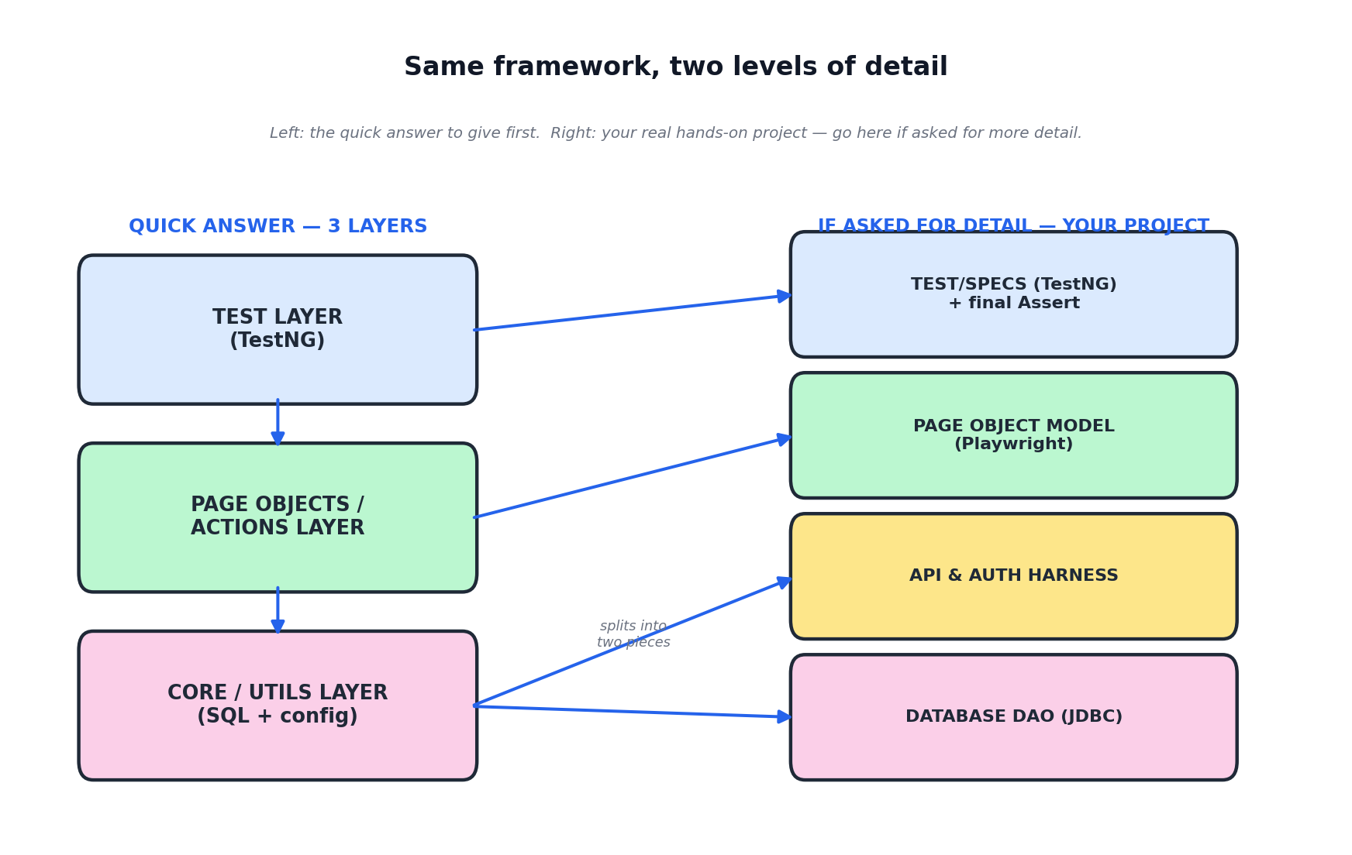

2. End-to-End Payment Strategy & SQL
Draw this in the center of the board if he asks how to test a payment app.
[ API Request ] ---> [ Playwright UI ] ---> [ SQL Database ]
(Injects/Seeds Data) (Submits Payment) (Validates Records)
Write this simple code on the board next to the diagram:
String uiTotal = "150.00";
String dbTotal = database.getPaymentAmount(transactionId);
assertEquals(uiTotal, dbTotal);
🗣️ What to say out loud:
For payments, I use an End-to-End strategy.
First, I use APIs or the UI to complete a transaction.
Then, my framework connects to the database using SQL.
I run a SELECT query to fetch the transaction record.
Finally, I use an assertion to compare the UI data against the database. They must match 100%.
Note: This is the same pattern as your real hands-on project (RegisterServer + UsuarioFormPage + DbHelper) — just applied to a payment instead of a user registration.

3. The Core CI/CD Pipeline & Git Workflow
Draw this horizontal timeline on the right side of the board using clear, sequential blocks.
+-------------------------------------------------------------------------------+
| THE CI/CD PIPELINE |
+-------------------------------------------------------------------------------+
[ 1. COMMIT ] ---> [ 2. BUILD ] ---> [ 3. DEPLOY ] ---> [ 4. TEST ]
(git push code) (Java compiles) (Installed to QA) (Playwright runs)

Git Commands Reference
- git pull -> Fetches and merges the latest changes from the remote repository.
- git add . -> Stages all your new test scripts and modifications.
- git commit -m "msg" -> Saves your staged changes locally with a message.
- git push -> Uploads your local commits to GitLab, automatically triggering the pipeline.
🗣️ What to say out loud:
I integrate all my automation directly into the CI/CD pipeline. The process follows four clear steps:
COMMIT: I run git pull to update my code, write my scripts, and then use git push to send it to the GitLab repository.
BUILD: The pipeline triggers automatically, compiles the Java code, and checks for syntax errors.
DEPLOY: The pipeline automatically deploys and installs the new build into our cloud-hosted QA environment.
TEST: As soon as the deployment finishes, my Playwright regression suite executes automatically against the live application.
If any step fails — whether it is the Build, the Deploy, or the Test — the pipeline stops immediately.

4. Root Cause Analysis (RCA)
Draw a big arrow pointing backward on your pipeline graph from Test to Deploy if a test fails.
+-------------------------------------------------+
| ROOT CAUSE ANALYSIS (RCA) |
+-------------------------------------------------+
[ TEST FAILS ]
|
v
[ Arrow Back to DEPLOY Stage ]
|
v
Check UI Layer -> Test Data -> Network Latency -> Infra Logs
🗣️ What to say out loud:
When a pipeline test fails with a TimeoutError, I use a four-step Root Cause Analysis:
UI Layer: I check if developers changed the element selectors.
Test Data: I check if another parallel test modified the same data.
API Layer: I check for network latency or slow API responses.
Infrastructure: I check if the Docker container ran out of memory.
My Action: If it is a bug, I check the Deploy step logs to confirm recent code changes and share the Playwright trace with developers. If it is a test issue, I fix the selector or use API data seeding.

5. Essential Playwright Code Syntax & Scenarios

Complete UI Test Case (Login & Click Pay)
@Test
public void testSuccessfulPayment() {
page.navigate("https://fiserv.com");
// Interact with fields using User-Facing Locators
page.getByLabel("Card Number").fill("4111222233334444");
page.getByLabel("Amount").fill("150.00");
page.getByRole("button", new Page.GetByRoleOptions().setName("Pay Now")).click();
// Assert the result using Playwright auto-waiting assertions
assertThat(page.locator(".success-message")).isVisible();
}

API Automation Test (Validate Response)
@Test
public void testVerifyPaymentAPI() {
APIRequestContext request = playwright.request().newContext();
APIResponse response = request.post("https://fiserv.com",
RequestOptions.create().setData("{ \"amount\": 150.00 }")
);
assertEquals(201, response.status());
assertTrue(response.text().contains("APPROVED"));
}

Database Connection & Verification (SQL Utility)
public String getPaymentStatusFromDB(String transactionId) throws Exception {
String url = "jdbc:sqlserver://fiserv-db:1433;databaseName=Payments";
Connection conn = DriverManager.getConnection(url, "user", "password");
String query = "SELECT status FROM transactions WHERE id = ?";
PreparedStatement stmt = conn.prepareStatement(query);
stmt.setString(1, transactionId);
ResultSet rs = stmt.executeQuery();
String status = "";
if (rs.next()) { status = rs.getString("status"); }
conn.close();
return status;
}
Note: These three snippets are representative patterns, not literal code from a project you ran end-to-end. If Avinash asks "is this from a real project?", answer honestly: "This is the pattern I'd apply — the project I actually built and ran end-to-end uses SQLite, and I can walk you through that one in full detail." Then you can go as deep as he wants on your real project.

6. Testing Scenarios Design
Draw this 4-quadrant layout box on the board if asked how you categorize your automated test scenarios.
+---------------------------------------------------------------------------------+
| TEST SCENARIOS |
+---------------------------------------------------------------------------------+
| 1. HAPPY PATH (200 OK) | 2. NEGATIVE PATH (400 Bad Request) |
| Valid Card -> Approved | Expired Card -> Declined Message |
|------------------------------+---------------------------------------------------|
| 3. REGRESSION SUITE | 4. TEST ISOLATION |
| Runs automatically on CI/CD | API Data Seeding -> Fresh user for parallel runs |
+---------------------------------------------------------------------------------+
🗣️ What to say out loud:
Happy Path: I automate the positive flow. I simulate a valid user completing a standard transaction and assert that the API returns 200 OK.
Negative Path: I execute negative testing with invalid inputs, like an expired card, to verify the application safely displays the correct error alert and returns a 400 Bad Request.
Regression Suite: I group these core scenarios into a Regression Suite that executes automatically inside our CI/CD pipeline on every code change.
Test Isolation: To run tests fast in parallel, I use a TestNG @BeforeMethod to trigger an API request for data seeding. This generates a fresh, unique user right before the UI test starts, preventing data conflicts.

7. Data Cleansing & Data Quality (SQL Whiteboard)
Draw this query block directly on the board to show how you clean data, handle blank spaces, and catch empty inputs.
-- Cleaning empty spaces and converting blank fields to NULL
SELECT
id,
TRIM(customer_name) AS clean_name,
NULLIF(TRIM(payment_status), '') AS clean_status
FROM
source_transactions;
🗣️ What to say out loud:
To clean data, I use TRIM and NULLIF in my T-SQL scripts:
I use TRIM to remove trailing or hidden white spaces from text columns.
I use NULLIF to automatically convert empty string values into standardized NULL parameters.
This guarantees data consistency and prevents application crashes during the migration process.

8. Core Java Programming Syntax (Loops & Conditions)

The if-else Statement (Handling Environment Configs)
String environment = "QA";
String baseUrl;
if (environment.equalsIgnoreCase("QA")) {
baseUrl = "https://qa.fiserv.com";
} else if (environment.equalsIgnoreCase("STAGE")) {
baseUrl = "https://stage.fiserv.com";
} else {
baseUrl = "https://fiserv.com";
}
page.navigate(baseUrl);
Note: Fixed from the original draft — each branch now returns a different URL, so the if-else actually demonstrates what it's meant to demonstrate.

The for Loop (Looping Through Web Elements)
Locator paymentRows = page.locator(".transaction-row");
int totalRows = paymentRows.count();
for (int i = 0; i < totalRows; i++) {
assertThat(paymentRows.nth(i)).isVisible();
}

9. QA Engineering Vocabulary Checklist
Say each term out loud, then its example sentence, until it comes out smoothly.
Regression Suite (re-GRÉ-shon suit): Pack of tests run to verify code changes didn't break existing components.
Flaky Test (FLÉI-ki test): An unstable test that fails and passes intermittently without script changes.
Data Seeding (DÉI-ta SÍ-ding): Setting up fresh test data via APIs before running a UI test.
Test Isolation (test ai-so-LÉI-shon): Ensuring tests run completely independently with zero shared dependencies.
Schema Validation (SKÍ-ma va-li-DÉI-shon): Verifying the JSON response structure holds the correct technical types.

10. Short STAR Behavioral Scenarios

Scenario 1 — The Production Incident (dentsu)
Situation: At dentsu, a core platform feature failed during a production deployment.
Task: My task was to perform a Root Cause Analysis and find the failure.
Action: I analyzed the application logs and checked the backend performance trends. I found that a database migration script failed to update a column schema.
Result: I provided the exact logs to development. They fixed the database, and we resolved the incident quickly.

Scenario 2 — Handling a Disagreement with a Developer (Test Pro)
Situation: I found a backend bug where an API returned an incorrect status. The developer rejected it — he said it worked on his local machine.
Task: My task was to provide clear technical proof without creating tension.
Action: I did not argue. I captured the exact JSON payload from Postman and recorded a Playwright trace showing the exact log line where the backend code crashed.
Result: The developer saw the data and understood the issue immediately. He fixed the bug in an hour, and we released on time.

Scenario 3 — Data Migration Validation (Victory World Church)
Draw this data mapping diagram on the board while telling the story.
[ Source DB ] ---> [ ETL / Mapping Matrix ] ---> [ Target Azure DB ]
|
v
[ My T-SQL Validation ]
- Checked for NULL / Blank Spaces using TRIM()
- Record Count Reconciliation (10k+)
Situation: We migrated over ten thousand records to a cloud environment in Azure.
Task: My task was to design the validation strategy to catch missing data or empty fields.
Action: I analyzed the schema mapping matrix. I wrote advanced T-SQL scripts using IS NULL and TRIM to find hidden blank spaces and data truncation.
Result: I identified over 200 mismatched fields. We corrected the mapping rules and achieved 100% data accuracy during the release.

11. Key Speeches & Survival Phrases

About AWS vs. Azure
My recent experience is Azure-focused, but I work extensively with cloud applications, CI/CD pipelines, and Docker containers. The engineering principles are exactly the same. I can ramp up on AWS very fast.

The "Whiteboard Pause" Phrase (use this if you freeze or feel nervous)
Let me sketch this out on the board first to show you my thought process.
Note: Turn around, face the board, and start drawing Section 1, 2, or 3. Take a deep breath.

12. High-Value Questions to Ask Avinash
Pick 3, max 4 — do not ask all of them. A good combination: one technical (#2), one business/impact (#1), and the contract-expectations one (#3).

1. "What are the biggest quality or stability challenges the engineering team is trying to solve today?"
Why it works: It shows you want to find their pain points and fix them on day one.

2. "How mature is the integration between the Playwright automation suite and the current GitLab CI/CD pipelines?"
Why it works: It matches his technical leadership profile and proves you are thinking about deployment health, not just writing isolated tests.

3. "For this 4-month contract, what does successful delivery look like for you in the first 30 days?"
Why it works: It proves you have a fast execution mindset and want to deliver clean results immediately — especially relevant since this is contract-to-hire.

